Adding Inclusive Access Information Link Via Web Link
If you have signed up with the bookstore to participate in the Inclusive Access program and lower the cost to your students, you will need to add the Vitalsource tool to your course via Web Link. By doing so, your students will be able to see important dates through this link, in addition to the opt out option. If you are using coded courseware, the personalized access code will also now be available to students through Blackboard (in addition to the email from the Bookstore).
There are a few simple steps to get this setup and ready to go for your students. Below we will walk you through adding a Web Link tool that make this information available.
- Within your Course, once you decide where the link should reside, select Build Content (2). In the dropdown select the “Web Link.”(3) option.
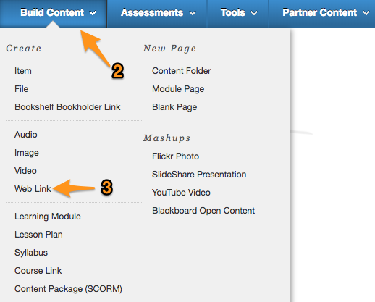
- On the “Edit Weblink” screen:
  - Enter the name you would like your students to see in the “Name” field. We recommend using something like “Inclusive Access Information” or similar.
  - In the URL field please add the following URL: https://bc.vitalsource.com/books
  - Make sure to click the “This link is to a tool provider” checkbox and then click submit.
- This will add a new option in your course module that the students can use to access information about their Inclusive Access course.

- When the student clicks on the new link that you have added they will see an image of the materials for the course, along with an opt out and “Reveal Access Code” button, where applicable.
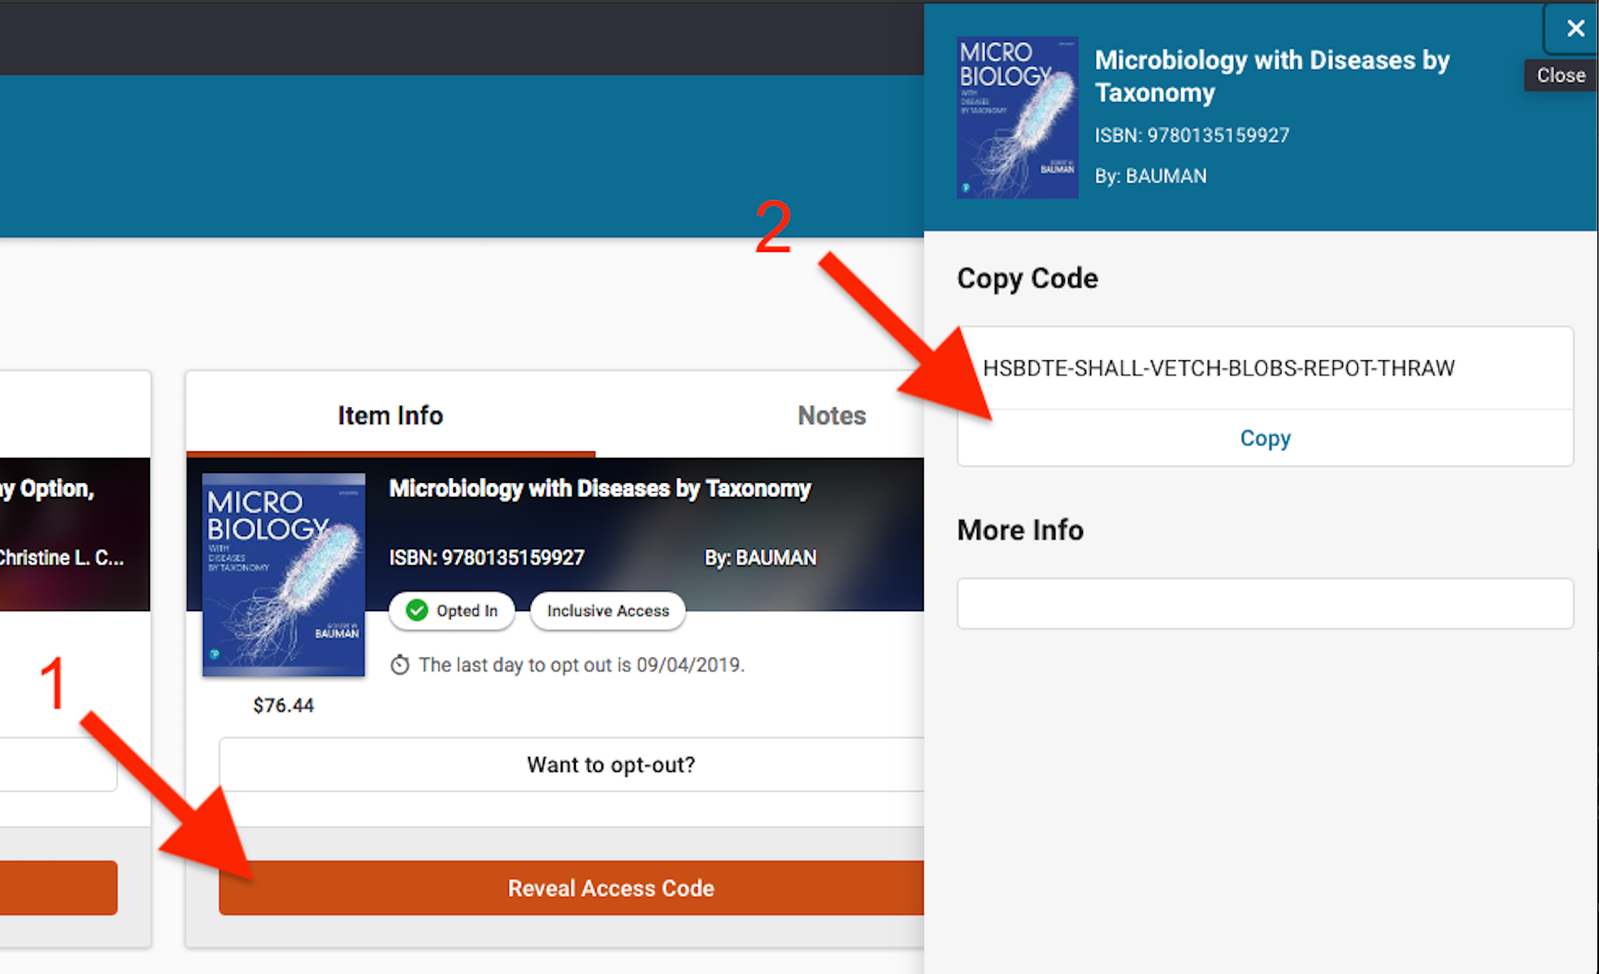

As an instructor you will not see the options to opt out or reveal access code, but your students will based on the enrollments in your course.

